HOMEWORK unit 8 (grade 4)
I. Write a, an or some
1. some pastry 2. ……..onion 3……..lemon
4. ….. cucumbers 5……..cereal 6…….melons
7 ……..egg 8……..bread 9..……orange
10…….milk 11…….water 12……meat
II. Complete
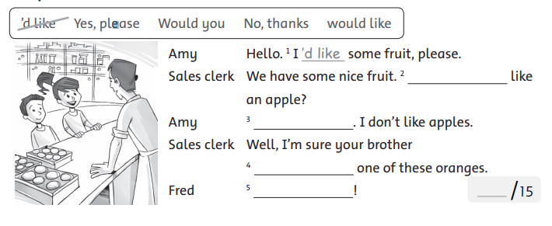

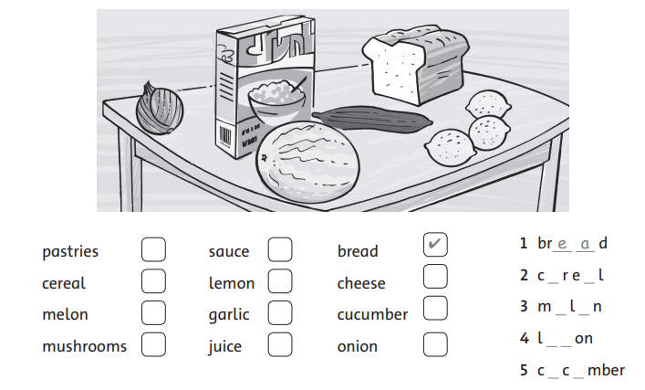
III. Check (v) the foods you can see. Then write the words.

IV. Put the words in the correct column.
date bread banana fruit lemon milk apple rice bread onion egg meat cookie juice cereal cucumber

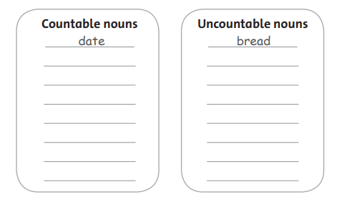

Answer key
I. Write a, an or some
2. an onion 3. a lemon 4. some cucumbers
5. some cereal 6. some melons 7. an egg
8. some bread 9. an orange 10. some milk
11. some water 12. some meat
II. Complete
2. Would you 3. No, thanks. 4. would like 5. Yes, please.
III. Check (v) the foods you can see. Then write the words.
2. cereal 3. melon 4. lemon 5. cucumber
IV. Put the words in the correct column.
Countable nouns | Uncountable nouns
banana | fruit
lemon | milk
apple | rice
onion | bread
egg | meat
cookie | juice
cucumber | cereal

